

Finding correct donor in correct time

Get notified when perfect match been found

Reduce time consumption

Consume more time to reach out donors

Finding Trusted Blood Banks

Getting a donor

Is it necessary to donating via an dedicated application?

Donating plasma

Notification about Matched donor

Less Time consumption

Plasma shortage

Less Effort when compared to other methods of getting plasma

Finding perfect and suitable donor

Easy way of getting/donating pllasma

PLASMA DONOR APPLICATION

EMPATHY MAP

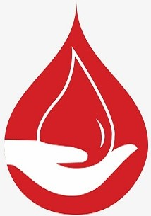

Having a application dedicated for donation of plasma is necessary?

By giving our details in this application,is that safe?